In collaboration with Peterborough Dioese, we have collated a list of non-confessional songs to aid your collective worship.

power in me
Sing - Gary Barlow & the commonwealth band lyrics
Sing Hosanna - He’s Got The Whole World In His Hands | Bible Songs for Kids
When I needed a Neighbour (with Lyrics)
One More Step Along the World I Go (5vv) [with lyrics for congregations]
Colours of Day (Light Up the Fire - 3vv+refrain) [with lyrics for congregations]
Together by Songs for School. A song to celebrate unity, community, and belonging. - YouTube
Hope (Official Lyric Video) - Worship For Everyone - YouTube
Love In Action by Worship for Everyone, Nick & Becky Drake | Invubu
Oh What a Day
Out of the Water – Worship for Everyone
One World by Songs For School. Creation Care & Harvest song.#climatechange #climate #creation #world
All Through History (Official Lyric Video) - Nick & Becky Drake // Worship For Everyone
Big Family Of God (Official Lyric Video) - Nick & Becky Drake // Worship For Everyone
Shine (From the Inside Out) - Remix - Children's Sing Along Worship Lyric Video
Kids Worship Motions: I Can Do All Things (Phil 4:13) (Motions Video)
"Fruit of the Spirit" (Galatians 5:22-23) SONGS | Sing the Bible Vol. 4 | Slugs & Bugs
May the God of Hope Lyric Video with actions - Doug Horley/Duggie Dug Dug Official Video
Sing Hosanna! Norman St Primary School & St Cuthbert's, Carlisle.
https://youtu.be/7it5W1FVtTs?feature=shared Peace Like a River
https://youtu.be/cKkbIZtqhyQ?feature=shared This Little Light of Mine
Nick and Becky Drake have made a of videos with Makaton that may be useful for SEND worship. (See below) but the link is here: Worship For Everyone - YouTube
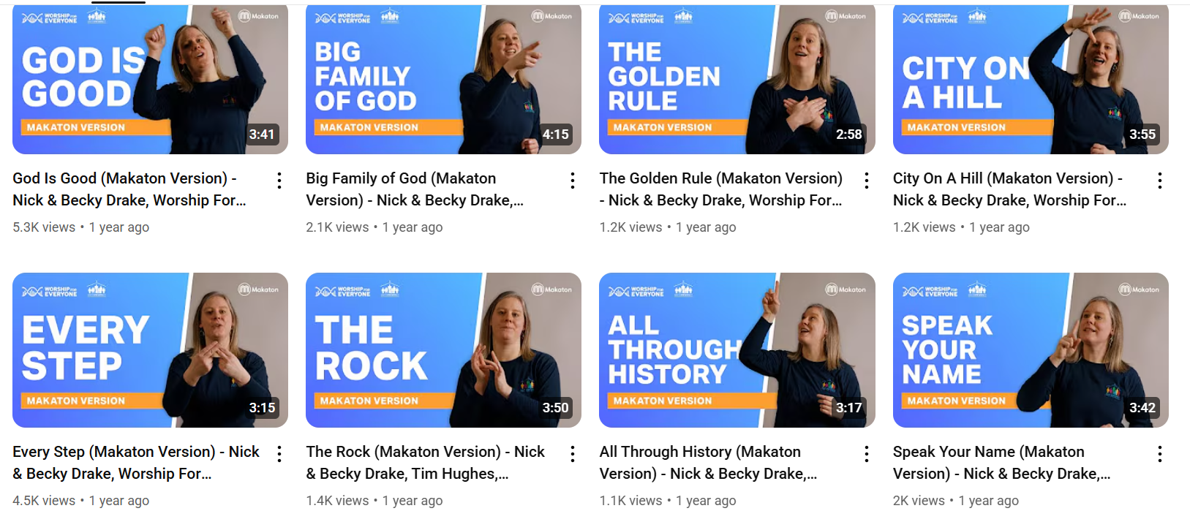
Songs for schools – a good bank of these on here: Songs For School - YouTube
iSing Pop: Scroll down to see songs and some with dances. There’s also some stories that you could use for Collective Worship: iSingPOP - YouTube

