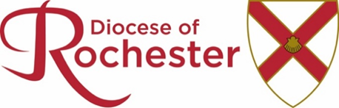

THE BOARD OF EDUCATION COMPOSITION

Following reconstitution, the Board of Education composition will be as follows from the 1 January 2022:
- The Bishop of Rochester
- One person nominated by the Bishop of Rochester
- Six persons elected by the Diocesan Synod (three clergy and three lay)
- Not less than three or more than six persons co-opted by the Board. Two members shall be persons currently serving as head teachers (one in the primary stage and one in the secondary stage) of Church of England schools or academies within the Diocese and
- The following local authorities shall each be entitled to nominate one person to attend meetings of the Board on its behalf without voting rights.
  - The Council of the London Borough of Bexley
  - The Council of the London Borough of Bromley
  - Kent County Council and
  - Medway Council

