Fresh Approach Collective Worship Planning
Year 1 Term 2: Learning from David in ways that make the world a better place

Week 1 | David develops his special gifts
Week 2 | Remembrance Sunday (14 Nov)  Children in Need (12 Nov)
Week 3 | Anti-Bullying Week (15-19 Nov 2021)  The theme for Anti-Bullying Week 2021 is One Kind Word  More details can be found at  https://anti-bullyingalliance.org.uk/anti-bullying-week/anti-bullying-week-2021-one-kind-word
Week 4 | David trusts God for his choices
Week 5 | David becomes King
Week 6 | Advent
Week 7 | Christmas
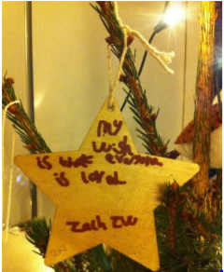
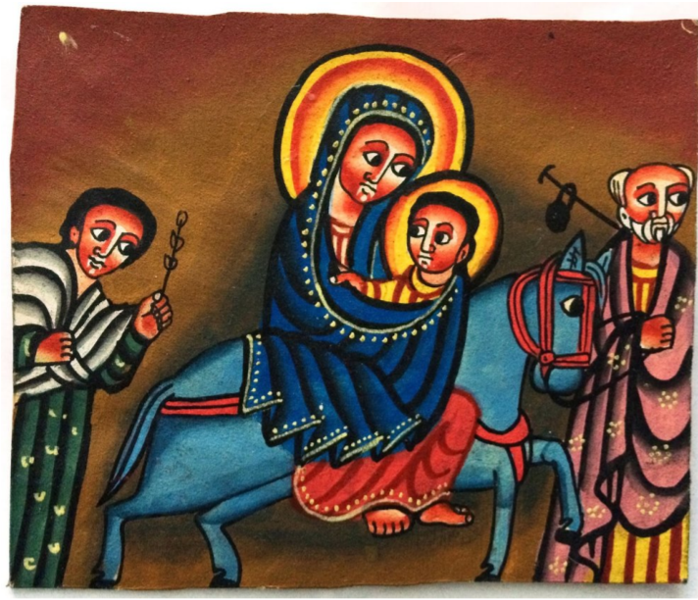
The themes for this term encourage commitment to making the world a better and fairer place by looking at the rich and varied life of an important character in the Old Testament called David. During this term, we also consider Remembrance Sunday, Anti Bullying week and Children in Need. We also spend time marking Advent and celebrating Christmas.
Learning from David in ways that make the world a better place
Liturgical colour | Monday | Tuesday | Wednesday | Thursday | Friday
Week 1: David develops his special gifts | WHO AM I?  I Samuel 16, 17 (verses referenced below)  I wonder what you would like to be later on your life? I wonder how the things that you learn and do now might help you to achieve your aims in life? We are going to think of an important figure in the Bible whose early life helped to shape who he would later become.  There are some images of David that you might use as clues that you can search on the internet. Using less familiar ones and building to things more likely to be recognised might work.  Alternatively, you could give a fact file item by item or interview someone in role play using information like this:  Address? Bethlehem in Judah  Age? 15 but everyone keeps telling me I am ‘only a boy’ (I Sam 17:33,42)  Birthday? Not sure  Brothers and sisters? 7 brothers  Dad’s name? Jesse  Favourite sandwich filling? Cheese (this is what David takes to the soldiers in I Sam 17:17,18)  Hobbies? Play the harp, write songs, practise with my catapult and stones  What would you like to be in the future? I am a shepherd now and an armour bearer for the king, but would like to be a great musician, soldier or possibly even king (I Sam 16:21,23, 17:15)  I wonder if you get any sense of the person that God was helping David to become?  Dear God, thank you that you are always there to help to guide and shape our lives. Thank you that we can trust you for our present and for our future. AMEN | GOD CALLS DAVID TO BE KING  1 Samuel 16  Look at some book covers that do not necessarily help you to know much about the book – I wonder if you know what this book is about or what it will be like by looking at the cover? I wonder how we would find out if we are right? Perhaps we should not always judge a book by its cover. There is a verse in our Bible passage today that says something similar,  People look at the outside of a person, but the Lord looks at the heart I Sam 16:7  The story about David today is all about not judging by appearances – use an appropriate Bible version or a retelling like the one here:  https://www.assemblies.org.uk/pri/2400/davids-calling  or  https://www.youtube.com/watch?v=RJa-X5BX36k  or  https://www.youtube.com/watch?v=g9Obyj-BPWE  Dear God  We thank you for surprises and how you look at our hearts and not what we look like. Help us to see people not as they are now but as they could be. AMEN  God anoints David to be King of Israel as a young boy. I wonder why God chose him? I wonder if he will be the right choice?  God doesn’t always follow and do what people expect. God has a job and plan for each of us but I wonder what it will be? | DAVID THE MUSICIAN  Psalm 138:6-7  The Psalms in the Bible are mostly attributed to David. We are told he played the harp and was an accomplished musician.  I wonder what are your favourite songs? I wonder what type of songs you like best and what are the main themes of these songs? (you could play music with different sorts of ‘moods and talk about them).  The songs (Psalms) that David wrote also had different moods and themes – some praise God (eg Psalm 150), some ask God for help and guidance (eg Psalm 119), others talk about what God is like (eg Psalm 93), some ask questions about our part in the world (Psalm 139).  I wonder why David wrote this one? I wonder how he was feeling and what might have been happening in his life?  Though I walk in the midst of trouble, you preserve my life.  You stretch out your hand against the anger of my foes;  with your right hand you save me.  Psalm 138: 6-7  I wonder how it might help us today?  Christians continue say the Psalms today and to sing songs based on the Psalms in different ways, both traditional and contemporary.  https://www.youtube.com/watch?v=HOEwCzfyVC4  https://www.youtube.com/watch?v=2MKb32C66-I  https://www.youtube.com/watch?v=Ut5LBsi-YGE | DAVID BEGINS TO WORK FOR KING SAUL  1 Samuel 16: 14-23  Use age-appropriate versions of the story/details about David so far. Add the story of how he began to play his harp for King Saul when he felt sad and anxious.  I wonder what you remember about David?  - came from a large family  - shepherd boy,  - played the harp  - chosen as king  - wrote songs and God’s spirit was on him  I wonder how all these attributes might help David as he got older?  We know from the Psalms that David likes to play his harp and to write poetry and prayers. I wonder if we could write a class Psalm together.  Psalm 150 might provide a really clear structure and help the pupils to think of new ways to ‘Praise the Lord’.  I wonder what God given qualities you have and what God-given qualities you can see in others in the class and school? (both children and adults)  Generous God, we give you thanks for the gifts and talents that you have given us. Help us to make the best use of them that we can and to serve you and others in all that we do. Amen. | CELEBRATE  Our gifts and talents  Think about the ways in which people have used their gifts and talents to enrich the life of the school community this week. Perhaps they could be linked in some ways to David’s gifts and talents.  Dear God, We thank you for our talents and gifts. Help us strive to use them wisely for the benefit of our special community. Give us the grace to be humble, respectful and tolerant this day and all the days of our lives. AMEN
Week 2 : Remembrance | PEACEMAKING  Matthew 5:9  Find appropriate images as suggested to think about marking Remembrance Sunday  Image of poppy/poppies: I wonder what you think of when you see these? For most of us, it will be ‘Poppy Day’ or more correctly, Remembrance (Armistice) Day – when across the world, the nations remember the many acts of courage, selflessness and service of those who fought in past wars, and those who are still doing so. We choose to remember in this way as an act of gratitude.  Image of WW1 as appropriate: Since the end of the Great War (also known as WW1) in 1918, which people said was the ‘war to end all wars’, poppies have become a symbol for this act of remembering and being thankful.  Image of War Memorial: Our peace was won at a very great cost, which is why on Remembrance Day each year, we hear the words ‘At the going down of the sun, and in the morning, we will remember them’, as we think of those who gave so much so that we might live at peace….  Words of Jesus  Jesus once talked about being a ‘peacemaker’ – and that our world would need people who would be prepared to act in ways that would bring peace – which is perhaps not what you’re expecting to hear as we’ve been thinking about the great cost of war!  I wonder if you can think of practical ideas through which you can be a good peacemaker? (pupils could be invited to add ideas on poppies for a display)  Use this song as a prayer:  https://www.youtube.com/watch?v=D_SOqy7glSw | THE PEACE PRAYER  Matthew 5:9  The Peace Prayer was written by Satish Kumar and adopted by the Prayer for Peace Movement in 1981. It is used peoples of different faiths across the world. There is a Week of Prayer for World Peace in October and a World Peace Day as well. It is also an appropriate focus for the week when we focus on Remembrance Sunday.  I wonder if you can think of some sets of opposites? We are thinking about a prayer with some opposites within in today.  The Peace Prayer:  Lead me from Death to Life  From Falsehood to Truth  Lead me from Despair to Hope  From Fear to Trust  From War to Peace  Let Peace fill our heart, our world, our universe  I wonder how the world might be a better place if we could move it from one set of the opposites to the other? I wonder what the world would look like then? I wonder how a world like this would honour those who gave their lives in the cause of peace?  Give time to reflect on these words and use the prayer as part of your worship.  This song is based on the words of the prayer  https://www.youtube.com/watch?v=QICK2UGw04A  Pray for those places in the world which need the touch of peace and peacemakers.  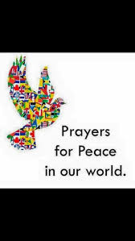 | PEACE AND FORGIVENESS  Matthew 18: 21-35  As during and following war, true peace often demands forgiveness.  Use  - Large clear vases filled with water  - Soluble vitamin tablets that cause the water to change colour  Find a story or tell a personal anecdote about when you or someone else needed to forgive another person. I wonder why forgiveness was needed in this story/anecdote? I wonder how the people felt after forgiveness had been offered and accepted? Read the Bible passage about what Jesus said about forgiveness.  Sometimes people do and say things to hurt us on purpose. Sometimes they don’t mean it, but it hurts anyway. Forgiveness is hard. Watch this tablet dissolve into the water – if we offer and accept forgiveness, it can be like this process. Encourage the pupils to watch until the tablet has completely dissolved. As the water changes colour, it’s a reminder that actions often have consequences and that the consequences may go on even after the person has been forgiven. Forgiveness itself may need to be an ongoing, conscious process. However, forgiving and being forgiven is often an important part of feeling at peace in body, mind and spirit.  Peace is costly but worth the expense (African proverb). I wonder how forgiveness might be similar?  Be aware that pupils may want to talk about their hurt feelings so make sure this is possible | MY SMALL BUT VITAL PART IN WORLD PEACE  Philippians 4:7  I wonder how we could try and follow the example of the peace of God described in our Bible verse?  This activity, adapted as appropriate to age group, offers the pupils the opportunity to think about their contribution to making and maintaining a peaceful society, both now and in the future.  Invite pupils to draw around their hand. On each finger write what you could do to bring peace to;  Your class – on your little finger  Your family – on the ring finger  Your street, or village or town – on your middle finger  The world – on your pointing finger  What do you hope to do to bring peace when you are grown up – on your thumb.  All the hand shapes could be used on a class or a school display together with the hands of many others in schools. Adults might also make a contribution.  Pupils could also write and pray their own peace prayers.  https://www.youtube.com/watch?v=lj9A4klqbqY | CELEBRATE  James 2:14-17  Children in Need is also marked today and you may be taking part in this – remembering and responding to the needs of others who need your help.  https://www.bbcchildreninneed.co.uk/  Remember that not all children feel safe or at peace in their lives. Take time to give thanks for those who respond with care, kindness and compassion in our school, your community and the wider world to make sure that all children can feel a sense of peace and happiness.
Week 3: Anti-Bullying Week | WE ALL NEED FRIENDS  I Samuel 19:1-10  Talk about the image: I wonder what is happening here? I wonder if you have ever seen anyone who is on their own? Sometimes people choose to be on their own: why might they make that choice? But would there be another reason that they are on their own? I wonder how we would know the difference? How does it feel to be left out? Why do people leave others out? Why do people choose not to help if they see someone who is left out?  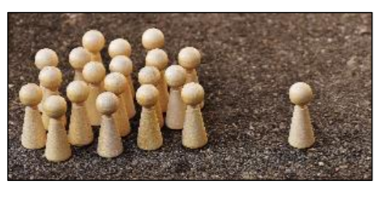  One of the things that happened to David was that King Saul tried to isolate him and leave him out because he knew that God had chosen David as the next king. Saul became jealous and attacked David in different ways – he even tried to kill David. David escaped and found people who supported him and helped him to become the king as God intended.  Leaving other people out in ways that mean that they have no-one to befriend or support them can be a form of bullying and we are going to think about how we make sure that bullying is not tolerated in our school over the course of this week. | WHAT DID JESUS DO?  Luke 19:1-10  Sadly, many pupils will have experienced bullying and be all too familiar with what it feels like to be bullied. Bullying comes in many different forms, including mental, physical and emotional. It could be as simple as ignoring someone in the class just because everybody else does, posting mean comments about someone online, or sharing a joke at someone else's expense.  Christians often ask themselves ‘What Would Jesus Do?’ to decide how they should treat others. The account of an individual whom everyone hated, Zacchaeus the chief tax collector, helps us to see how Jesus treated someone who had become isolated and ostracised.  Explore the story as most appropriate:  https://freebibleimages.org/photos/lumo-zacchaeus/  https://www.youtube.com/watch?v=DdOSWhqQwhw  https://www.brf.org.uk/product/nice-and-nasty-jesus-makes-friends-with-zacchaeus/  https://www.youtube.com/watch?v=NPedyvaPSpw  When Jesus stepped into this situation, his reaction to Zacchaeus was very different from the reaction of the people of Jericho, the ‘crowd’ in the story. Jesus changed everything – and he calls people who follow him to do the same. I wonder what this might mean for us, today? I wonder what we might learn from Zacchaeus about people who feel isolated and alone? I wonder what we might learn from this story about how easy it is to be a bystander in the crowd? I wonder how Jesus’ actions can help us decide how to treat people? | WHAT OTHER GOOD EXAMPLES CAN WE FOLLOW?  Isaiah 1:17  We all share the responsibility to take action if we witness the bullying of others. Bullies are able to continue because no one challenges what it is they are doing. Here are two people who did not let the ‘bullies’ win.  The story of Malala Yousafzai ‘Malala’s Magic Pencil’ is a story of one Muslim girl’s act of defiance, standing up for what she believed was right and good in her community, namely that girls should be allowed to attend school, just like boys. Although her actions met with conflict, and forced her to leave her home in Pakistan, her story ends hopefully, with her influence and voice changing the world and becoming the youngest ever Nobel Peace Prize winner (2014). You can find out more about her life and work here:  https://malala.org/  Desmond and the Very Mean Word by Archbishop Desmond Tutu  This is a story from this great man’s childhood and explores his response to an incident of bullying and how he was helped by the wise words of his friend Father Trevor (a number of versions are available on youtube but this is probably better read by you)  Lord Jesus Thank you for your example of being kind to all. Help us to include others in our work and play. Help us to stand up for those who feel left out and to do all we can to help them to feel included. Amen | MAKING THE RIGHT CHOICES  Isaiah 1:17  https://anti-bullyingalliance.org.uk/anti-bullying-week/anti-bullying-week-2021-one-kind-word provides ideas for exploring the theme this year.  Discuss how we can follow this advice from the Anti-Bullying Alliance appropriate to age group:  Include others: Make sure there is no one left by themselves in the playground, or ask others to play with you if they are feeling left out.  Celebrate difference: Choosing to celebrate difference, rather than be divided by discrimination and hate. If someone is different to you get to know them better and you will find you have more in common than you might have thought.  Keep your hands and feet to yourself: Never physically hurt anyone else.  Respect everyone: Choose to be kind, not mean.  Don't laugh at others: This can really hurt someone's feelings. We all need to play our part! If everyone works together and agrees to act this way, we can make a more powerful difference.  Light a candle and reflect:  Jesus, light of the world, help me to stand up for what is right. Help me to shine your light in the darkness so others may see that there is a way that is good and that is more powerful than the way that hurts others. Help us to follow you so we do not walk in darkness but have the light of life. | CELEBRATE  One Kind Word  ‘Ask if someone’s OK. Say you’re sorry. Just say hey’.  In a world that can sometimes feel like it’s filled with negativity, one kind word can provide a moment of hope. It can be a turning point. It can change someone’s perspective. It can change their day. It can change the course of a conversation and break the cycle of bullying.  Celebrate examples from school life this week – this is the theme of the Anti Bullying week campaign for 2021  Father God, You have placed Your children in a world where people push and shove to be first. But you have called us to view life from a perspective that considers others to be as important as ourselves. May our love and consideration for others grow and may the example of Jesus guide us as we make decisions that affect others and ourselves. Amen.
Week 4: David trusts God for his choices | DAVID AND GOLIATH  I Samuel 17  Be sensitive to pupils’ needs in asking some of the questions today.  I wonder if there has ever been something in your life that feels like a big barrier that you cannot get over or around? I wonder if you ever felt that you needed some sort of shield to protect you from something that was difficult for you?  Today’s story features an enormous barrier/problem and also shows that we do not always need a real shield for protection if God is on our side.  There are many ways to tell the story of David and Goliath – remember that he was simply delivering food to his older and stronger brother who were serving in King Saul’s army when he found the courage and the cleverness to face and defeat Goliath.  https://www.brf.org.uk/product/david-and-goliath-a-very-loud-story-with-drums-and-percussion/  https://www.youtube.com/watch?v=7zLAcUZkxHA TO 3.30 ONLY  https://www.youtube.com/watch?v=Bsup35Xixtk  https://www.youtube.com/watch?v=Bsup35Xixtk TO 3.45 ONLY  This is a classic story about the small guy defeating the bigger guy. I wonder what it was that actually gave David the power to win? (David’s powerful faith in God, which is a key point for Jewish believers and Christians. I wonder what this story is saying to you about courage, or hope, or perseverance, or taking on responsibility for something in ways that will act as a shield or as a help in overcoming a big problem? | KING SAUL BECOMES JEALOUS OF DAVID  1 Samuel 24  I wonder how Saul might have treated David after he rid the Israelites of the threat from the Philistines by killing Goliath? I wonder how you would have treated someone who did something really amazing and brave for you even though it was dangerous?  It might not be how you would think  https://www.youtube.com/watch?v=41vnmcocZ1A is a video explaining why Saul was jealous of David.  I wonder if you think that David did the right thing? I wonder what damage was done to Saul and David by the jealousy?  Being jealous of others is  http://flamecreativekids.blogspot.com/search/label/David%20and%20Saul – here is an object lesson on choosing not to fight back.  You will need two jars or bottles with lids, white vinegar, water and bicarbonate of soda. Put neat vinegar in one jar and a mix of vinegar and water in another jar. Talk about what it is like when people make you angry. Add half a teaspoon of bicarb to the water/ vinegar jar. The mixture will fizz a little but nothing more. Put a lid on the jar.  Next, put a spoonful of bicarb in the vinegar jar and add another spoonful as well. The mixture will fizz up and explode out of the jar (best to keep the jars on a tray to collect the fizzy liquid! David chose not to ‘explode’ like the second jar. He chose to be a better person than Saul, to do the clever thing and the thing that Jesus tells us to do- to turn the other cheek. He didn't fight back against Saul and kill him, instead he chose to try and keep a lid on the situation by doing the right thing.  I wonder what we do when faced with similar choices? | DAVID AND JONATHAN – AN EXAMPLE OF GREAT FRIENDSHIP  I Samuel 20:17-23  I wonder how friends mark their friendship with each other? I wonder if you have ever given a gift to a friend like a friendship bracelet or made a promise to a friend? I wonder what colour friendship might be? I wonder what makes a best friend and I wonder how friends prove they are friends?  Explain that Jonathan (who was the son of King Saul) and David stayed friends all their life, despite enormous pressures and dangers. Saul had become jealous of David and wanted to kill him so David had to run away. As the future king, David needed to know what was happening at court and his trusted friend Jonathan helped him – the story in the Bible passage tells about one way of doing this which was risky and dangerous. You might also have other examples of how far true friends will go to help and support each other.  Use some ‘speech bubbles’ and invite pupils to fill in the missing word or words in the phrase, ‘Friendship means…’ and use as a basis for prayers about friends and friendship.  Think about this verse  Two are better than one, because they have a good return for their labour: If either of them falls down, one can help the other up. But pity anyone who falls and has no one to help them up. Ecclesiastes 4:9-10 | DAVID WAS NOT PERFECT  Psalm 51: 1-2, 7-10.  I wonder if you can think of a time when you have done something really bad and you regretted it straight away?  David always tried to follow God and his ways, but he started to make lots of wrong decisions even when he became the king of Israel. Those mistakes hurt him and others and they resulted in some really bad things happening. David also disobeyed God and his laws. Each time David disobeyed God, David said he was sorry and admitted his mistakes and God forgave him. God used David despite his mistakes. We all make mistakes and God can use us to help, guide and support others just as he did David.  The words of David in Psalm 51 show how he felt about his mistakes and the prayer he made to God for forgiveness.  http://flamecreativekids.blogspot.com/search/label/sorry Use one of these creative prayer activities to talk about importance of saying sorry and admitting mistakes.  The words of Psalm 5:8 could be used as a prayer for how to walk a better path going forward:  https://www.youtube.com/watch?v=XLtIylXJ3V4 | CELEBRATE  God’s goodness and generosity  Psalm 33 2-7  Praise the Lord on the harp.  Make music for him on the ten-stringed lyre.  ³ Sing a new song to him.  Play well and joyfully.  ⁴ God’s word is true.  Everything he does is right.  ⁵ He loves what is right and fair.  The Lord’s love fills the earth.  ⁶ The sky was made at the Lord’s command.  By the breath from his mouth, he made all the stars.  ⁷ He gathered the water in the sea into a heap.  He made the great ocean stay in its place.  You could recognise people who have shown goodness and generosity in school this week.
Week 5: David becomes king | DAVID BECOMES KING  2 Samuel 5:1-12  You shall shepherd my people Israel and you shall become their ruler (v2)  I wonder what makes a good king or a bad king or queen? Perhaps use some examples of kings and queens that the pupils know about and ask if they were good or bad rulers and what evidence the pupils have to back up their opinions.  David had waited a long time (almost 20 years) to become king, but finally God’s promise happened. I wonder how David felt when he finally became king? I wonder what David had learned in all the years of waiting that would help him to become a good king? I wonder if he had learning something about trust and about wisdom?  Proverbs 3:5-6 “Trust in the LORD with all your heart and lean not on your own understanding; in all your ways acknowledge Him, and He will make your paths.  David followed God’s paths, it had been difficult at times and he had messed up, but he trusted in God and trusted him to help him make most decisions.  I wonder what this story teaches about God and his promises? I wonder if we trust in God to keep his promises like David did?  A Christian song about God’s promises  https://www.youtube.com/watch?v=HCUIDB0C2_Y | DAVID THE LEADER  Psalm 78:72  And David shepherded them with integrity of heart; with skilful hands he led them.  I wonder what makes a good leader? I wonder if you can think of any examples and explain why you chose them? I wonder if you have ever followed a good leader?  I wonder if you can think of 3 words which describe what sort of a leader David was? I wonder how the skills and attributes which God gave him helped him to be a good leader? I wonder what we can learn from David about leading people? I wonder if there are ways that we could follow David’s example is doing as God would do?  In II Samuel 22: 2-3, we see how David praises God for who God is – protector, fortress, shield and saviour. Find images to help pupils to think about these characteristics of God. I wonder if these qualities helped David to follow God’s example? I wonder if they can help us too?  This song with actions draws on some of the images  https://www.youtube.com/watch?v=1qZWK8ZE2Pk  without actions  https://www.youtube.com/watch?v=vxoggZ2ueJ0  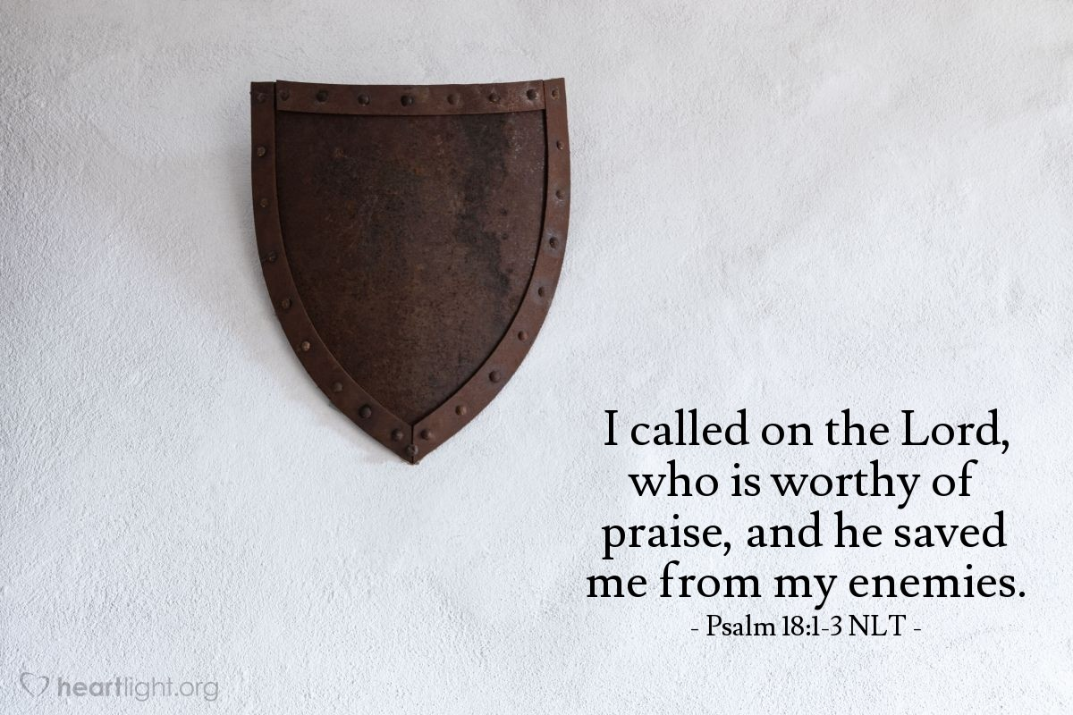 | KING DAVID AND JESUS  Isaiah 9:7  He will rule as king on David’s throne and over David’s kingdom. He will make it strong, by ruling with goodness and fair judgment. He will rule it forever and ever.  As we look forward to Christmas through Advent, we will be focussing on the prophecy of Isaiah about what the promised Messiah would be like and who he would be. The words of Isaiah say that he will be a king like David and rule over David’s Kingdom for ever. He will be a greater and more enduring king that even David was able to be.  Christians believe that in God’s kingdom, everything is good and fair. I wonder what that might look like?  Here is a summary of some of the tings that Jesus said about his kingdom when he was on earth.  https://www.youtube.com/watch?v=hv2P2y1bCcU  Christians are called to bring God’s Kingdom to earth here and now, in the way that they love and treat others. At Advent, as at all times, we will continue to pray ‘Your Kingdom come’ (words in the Lord’s prayer), remembering that Jesus is the king who is coming to reign on David’s throne. | THE LORD IS MY SHEPHERD  Psalm 23  Read or listen to this Psalm written by David. There are a number of suggestions to help you to ensure that this is explored in an age-appropriate way. There are also versions in children’s Bibles and children’s books. Provide time for reflection on the words and what it says about what God is like.  There are spoken and sung versions of this Psalm.  https://www.youtube.com/watch?v=2FK6NlUQbDo  https://www.youtube.com/watch?v=-NuUo-igXDU – this includes time for personal reflection  https://www.youtube.com/watch?v=K6fM4_8VU-8  https://www.youtube.com/watch?v=cO6bDmS6hXc  Songs  https://www.youtube.com/watch?v=4cp478Gxs-0  https://www.youtube.com/watch?v=A-qLa_2GPcM  https://www.youtube.com/watch?v=yLxdb3ov-zE  https://www.youtube.com/watch?v=syJFsLZmO8o  You could create a school display to which pupils could add their comments and questions about this Psalm.  Remember that David wrote this Psalm. I wonder what it tells you about David and how he feels about God? I wonder why it is an important Psalm for Christians? I wonder what it says about God and God’s relationship with people? | Celebrate  By looking forward  If you have not already, you might want to bring out your Advent wreath and explain how a similar wreath used in many churches leading up to Christmas. Set the scene for a time of waiting before the time of Christmas celebration.  Advent angels: This is an idea to cheer up your staff during these challenging last few weeks of term. Quite a few schools have done it and say that it has been good for morale! The idea and a poster for your staff room: https://www.cofeguildford.org.uk/education/christian-distinctiveness/advent-and-christmas  Advent Window: How about creating an advent calendar in your window for people walking past your school, changing the picture each day? You could use the themes of hope, peace, love and joy or the names of Jesus from Isaiah.  Thanks to Guildford Diocese for these ideas
Week 6: think about creating a display of images which enrich understanding of the names explored this week | ADVENT: THE ONE TO COME  Isaiah 9:2  Isaiah was a prophet in the eighth century BC, working in the south of Israel. Through his writings he brings a message of warning to the people of God, because they are not living in the way they should, but he then has a message of comfort for his readers as they go through difficult times. The third part of Isaiah looks forward to the distant future when there will be a new heaven and a new earth. These different voices of the prophet correspond to three different sections of the book, but it is the message of hope that Christians turn to during the season of Advent, as they get ready for the mystery of Christmas.  I wonder what you are looking forward to today? I wonder how you have felt when you were waiting for a special day, your birthday, or a wedding? Advent is a time of wating and anticipation. Show some pictures of familiar cartoon characters, famous people or even wild animals. With talk partners, choose some adjectives that you would use to describe the character e.g. gentle dolphin; fierce tiger; greedy Homer; brave Florence [Nightingale] etc. Light a candle in the dark and think of ways to describe this. I wonder how this helps us to understand Isaiah 9:2? I wonder what the people who lived before Jesus was born were waiting for?  You could use the Nick & Becky Drake song ‘I am a city on a hill’  https://www.youtube.com/watch?v=lTEadEftdnM or others that you know e.g. ‘This little light of mine’ https://www.youtube.com/watch?v=cKkbIZtqhyQ | ADVENT: THE ONE TO COME  Isaiah 9:6  In Advent, Christians prepare for Jesus – who comes to bring light in the darkness as we thought about yesterday. Long before Jesus was born, prophets including Isaiah brought messages from God about what the ‘Messiah’ would be like. Christians believe Jesus is the one they were talking about.  Today, we will look at some of the names that the prophet Isaiah used to describe Jesus. You could read the text together and pick out the key names, talking about the adjectives. His name will be Wonderful Counsellor. I wonder what a counsellor does? It is a person who gives advice, helps people to make choices. I wonder what choices you have already made today and what choices you make day by day? Talk about the choices we make. Not just what fruit at snack time, but more difficult choices. What we say to people… If we will help someone…. Sensitively explore some of the more difficult choices the children have made. (Be aware, for example, that where parents live apart children may feel that they have to choose between parents) Many Christians believe that Jesus will help them to make good choices.  His name will be Powerful God, Christians believe that God is a mighty, powerful God, that God can do things that seem impossible to humans, that God made the universe, including the stars millions of light years away. I wonder how Jesus showed God’s power? I wonder what you might have seen that might explain why Christians believe God is powerful? I wonder if there are there times when you wish God would show his power more in our world?  https://www.youtube.com/watch?v=TN5BaOGTmGs uses these words in a very famous piece of music | ADVENT: THE ONE TO COME  Isaiah 9:6-7  Here are some more of the names of the prophesied Messiah from Isaiah.  His name will be Father Who Lives Forever. Christians believe that God is with them for ever; he loves like a good parent loves their child. (You will need to be sensitive to the fact that not all children will have a father in their lives, and some may have negative experiences of fathers.) Create a mobius strip to illustrate this idea. If you run your finger round it, it never ends. Take a long strip of paper, half twist it and stick the ends together with tape. Invite a child to come and run their finger around the strip showing that it never ends. I wonder how it might help Christians to know that God is ‘everlasting’?  His name will be Prince of Peace. There is so much war and conflict in our world. I wonder why people find it difficult to make and keep peace. Our own hearts are often not at peace, but anxious and worried. Christians believe that Jesus brings peace – for them, and for our world.  Reflection  Now think about the names of Jesus from the past few days. I wonder which name you think is the most important? I wonder which you think might be most important to Christians this Advent time? I wonder which one you think our world needs most?  Thanks to Faith at Home and Guildford Diocese for the ideas used in this week of worship | CHRISTINGLE: THE LIGHT OF THE WORLD  John 8:12  This is an opportunity to explore the idea of the Christingle or hold a Christingle service in an age appropriate way (there are service outlines on the Diocesan website)  There is also additional information at  https://www.childrenssociety.org.uk/how-you-can-help/fundraise-and-events/christingle/what-is-christingle  Here is a simple prayer with some actions on the theme of light for younger children:  Light a candle in our world, O God (Thumbs-up symbol and wiggle thumb) let it brighten our faces (Hands at side of the face and wiggle fingers) that we may tell this world (Hands moving away from mouth) the time is arriving (Point to watch on wrist) when you will put on flesh (Mine putting on a coat) and walk among us. (Draw a circle in front of you with both index fingers) Amen  Taken from Roots Prayer and Prayer Activities | CELEBRATE  Using your Advent wreath  Here are some prayers as you light each candle  Jesus, you are light even in the darkest places. Help us to trust in you when we are lost or lonely. Shine hope into our hearts we pray.  Jesus, you are peace even when there is hatred. Help us to forgive like you when we are hurt or wounded. Bring peace into our hearts we pray.  Jesus, you are joy even in the saddest times. Help us to praise you when we are upset or grieving. Shine joy into our hearts we pray.  Jesus, you are love even if we are afraid. Help us to pray to you when we are scared or fearful. Bring love into our hearts we pray.  Celebrate those who have shown light, peace, joy or love in your school community this week.
Week 7: these suggestions provide  an opportunity to make use of your Nativity set/s in worship | CHRISTMAS JOY  Luke 2:10  I bring good news of great JOY that will be for all the people.  I wonder who said these words and how you think it relates to Christmas and the Christmas story?  Use a wooden crib set or printed-out pictures of the different characters in the Christmas story. Or you could simply write the names of those characters on post-it notes.  I wonder what makes Christmas so joyful for you? (be sensitive here to the circumstances of families – where Christmas may be a stressful time) I wonder whether it would still feel joyful if we didn’t have those things you talked about? I wonder if it is a real Christmas without presents, decorations and food?  You could watch this clip of The Grinch, https://www.youtube.com/watch?v=p8J-YmVs1j0 where the people of Whoville, whose presents and Christmas trimmings have been stolen away, sing joyfully anyway leading the Grinch to wonder: ‘maybe Christmas doesn’t come from a store?’  Look at the various characters from the Christmas story – which of these characters experienced and showed joy in the Christmas narrative?  Reflect on JOY and give thanks for the joy of Christmas by listening to this acapella version of the carol Joy to the World  https://www.youtube.com/watch?v=-Xo64Q2ucQ8 | CHRISTMAS COMFORT  Luke 2:10  Do not be afraid  I wonder who said these words? The angel did not only say that the good news would bring joy but also had to reassure the shepherds that they should not be afraid. I wonder why comfort is important.  Some reflective music:  https://www.youtube.com/watch?v=PNjiYj0wAxU  I wonder if there might be some others of our Christmas story characters who might have felt sad, anxious, frightened, angry or bereft? I wonder how the innkeepers who had no room felt, turning Mary and Joseph away? I wonder how the sheep felt, who were disturbed by a very bright light (angels) and then were taken (or left behind) to go and see a new baby? I wonder how Mary and Joseph’s family felt if they heard about Herod’s anger, but had to wait several years before Mary and Joseph returned? I wonder how you would COMFORT that character? Christians believe that because of Jesus, they can trust God and don’t need to live in fear. ‘Do not be afraid’ the angels said. Luke 2:10 They find COMFORT in knowing that God is with them, and that he knows what it’s like to live on earth in a difficult, dangerous (and smelly) situation!  Explore the #heartsforhomes campaign – how one school brought some comfort and joy to people living in care homes last Christmas:  https://www.picture-news.co.uk/blog/hearts-for-homes-picture-news-christmas-campaign/ | CHRISTMAS EMOTIONS (Mary)  Luke 1:26-2:20  At some moments, Mary is full of joy and excitement. At other moments, she must have been really worried and anxious. Mary shows us that it is completely human to feel lots of different emotions. I wonder how Christmas makes you feel? It’s unlikely you will feel the same about every aspect of the Christmas season – some of it may feel joyful, some of it may feel harder. For example, remembering someone who used to be with us who isn’t now, feeling disappointed about missing out on something you wished for or getting excited about a special Christmas activity. I wonder what helps you in the ‘down’ moments? I wonder what brings you COMFORT? I wonder how you might bring comfort to others in their down times?  (Remember, it is healthy to have both up and down times in our life - this clip from Inside Out may be an appropriate reminder of the need for all emotions https://www.youtube.com/watch?v=wTbfX9FBZC4 )  Christians believe they can come to Jesus with their worries, fears and sadness knowing that he empathises with them. He has felt all those feelings too – right from when he was a baby. His birth was not in a clean, safe hospital but a noisy stable. His family had to run away from a jealous king and he began his life in hiding, as a refugee. But he also experienced love, the excitement of visitors who thought he was special and the joy of angel choirs! | CHRISTMAS PRAYERS  Matthew 2:9-10  The wise men heard the king and then left. They saw the same star they had seen in the east. It went before them until it stopped above the place where the child was. ¹⁰ When the wise men saw the star, they were filled with joy.  The wise men found comfort after their long and challenging journey as the star stopped to show them that they had reached their destination and also joy that they had found the new King, Jesus.  In an age-appropriate way, discuss how they and others (eg charities) might bring comfort and joy to others this Christmas season. Cut out star shapes and punch a hole in the top, ready to hang. On each, ask the children to write their wish for Christmas – for themselves one on side and for other people (in their community or around the world) on the flip side. How might they wish to experience COMFORT and JOY this year? How might they bring COMFORT and JOY this year?  These prayers could be added to a tree in the class or as a whole school display and used in the final Christmas service.  Thanks to Faith at Home for the ideas used in this week of worship | End of Term – A time for a special celebration for your school and your families  Luke 2:10-11  This traditional carol brings together the idea of comfort and joy at Christmas:  https://www.youtube.com/watch?v=ku7ohU1IGls  or  https://www.youtube.com/watch?v=MQw83_zpbJg  Dear God,  Thank you for all the fun and excitement of Christmas.  Thank you for sending Jesus as a gift from you into this world.  As we look at the lights on the tree, remind us of the light which Jesus brought to the world.  When we sing songs and carols, remind us of the hope which Jesus brought.  As we open our presents, help us to remember that Jesus was the best gift of all.  As we share special times with family and friends, help us to share the light and hope of Jesus with others.  AMEN

